Traditional Service 8:30 am

Prelude | In His Time  (Music by Diane Ball, Arr. by Carl Seal)
Welcome & Announcements
Joining God’s Mission | Night of Worship
Call to Worship
This is the day the Lord has made;
Let us rejoice and be glad in it
Hymn #579 | Immortal, Invisible, God Only Wise
Responsive Reading | Psalm 115 (NIV)
Not to us, O Lord, not to us, but to your name give glory,
for the sake of your steadfast love and your faithfulness.
Why should the nations say, “Where is their God?”
Our God is in the heavens; he does whatever he pleases.
Their idols are silver and gold, the work of human hands.
They have mouths, but do not speak; eyes, but do not see.
They have ears, but do not hear; noses, but do not smell.
They have hands, but do not feel; feet, but do not walk;
they make no sound in their throats.
Those who make them are like them; so are all who trust in them.
O Israel, trust in the Lord! He is their help and their shield.
O house of Aaron, trust in the Lord! He is their help and their shield.
You who fear the Lord, trust in the Lord!
He is their help and their shield.
Prayer of Confession (Unison)
Gracious God, you have given us the law of Moses and the teachings of Jesus to direct us in the way of life. You offer us your Holy Spirit so that we can be born to new life as your children. Yet, O God, we confess that the idols of this world have a strong attraction and that we often succumb to their lure. Give us the vision and courage to choose and nurture life, that we may receive your blessing.
(People silently offer their personal confessions to God.)
In Jesus’ name we pray, Amen.
Declaration of Forgiveness
Pastor: Friends, believe the Good News:
People: In Jesus Christ we are forgiven!
Response | Glory be to the Father | #961
Glory be to the Father and to the Son and to the Holy Ghost
As it was in the beginning, is now and ever shall be
World without end. Amen, Amen.
Passing the Peace
Prayer for Our Nation
God bless America, land that I love
Stand beside her and guide her
Through the night with the light from above
From the mountains to the prairies
To the oceans white with foam
God bless America, my home sweet home.
Hymn #492 | Come, Thou Almighty King
Scripture Readings | Exodus 20:4-6 & Colossians 3:1-7
This is the Word of the Lord
Thanks be to God!
Sermon | American Idols  Formed and Free:  Living Out the Ten Commandments
Musical Reflection | My Jesus, I Love Thee  (by Adoniram Gordon; arr. Arr: by Dan Forrest)
Doxology
Praise God from Whom All Blessings Flow
Praise God from whom all blessings flow
Praise Him, all creatures here below
Praise Him, above ye heavenly hosts
Praise Father, Son and Holy Ghost. Amen.
Communion
Invitation to the Lord’s Table
Apostles' Creed
I believe in God the Father Almighty,
Creator of heaven and earth
I believe in Jesus Christ, his only Son, our Lord,
Who was conceived by the Holy Spirit
and was born of the virgin Mary.
He suffered under Pontius Pilate,
was crucified, died and was buried.
He descended into hell.
The third day he rose again from the dead.
He ascended to heaven and is seated
at the right hand of God the Father Almighty.
From there he will come to judge the living and the dead.
I believe in the Holy Spirit, the holy catholic Church,
the communion of saints, the forgiveness of sins,
the resurrection of the body, and the life everlasting. Amen
Prayers of the People and the Lord’s Prayer
Words of Institution
Communion Music | Be Thou My Vision/Amazing Grace
 | (Composer: Traditional Irish Melody, Arr. by Brian Chung)
Hymn #601 | All Hail the Power of Jesus' Name
Benediction
Postlude | Light for a Dark World (Medley)  (Arr. by Marilyn White)

Worship Participants
Welcome & Sermon | Rev. Greg Buell
Announcements & Liturgy | Rev. Dr. Spencer Lundgaard
Contemporary Worship Leader | Luke Stoner
Praise Music | Village Church Worship Band
Director of Traditional Music | Dr. Yongmin Kim
Song Leader | Elaine Holmquist (8:30)
Scripture Reader | Storm Metzger (8:30)
 | Lois Morris (10:00)
Keys | Hyewon Jung (11:00)
All Music done by permission CCLI license #1582552

Contemporary Service 10:00 am
Welcome and Call to Worship
Praise and Prayer
 | Great Things
 | King of Kings
 | Prayer of Confession
 | All Hail King Jesus
Passing the Peace
Prayer for Our Nation God Bless America
Announcements
(Offerings are received weekly via mail and online giving at
https://villagechurchnorthbrook.org/give/ . Those attending live worship can leave their donations in the offering plates at the back of the sanctuary.)
Joining in God’s Mission | Night of Worship
Scripture Reading | Exodus 20:4-6 & Colossians 3:1-7
Leader: This is the Word of the Lord
All: Thanks be to God
Sermon | American Idols  Formed and Free:  Living Out the Ten Commandments
Communion
Invitation to the Lord’s Table
Apostles' Creed
Prayers of the People
Words of Institution
Closing Song | Christ Be Magnified
Blessing

Questions for Discussion
Opening Discussion
- When you hear the word “idol”, what comes to mind first, and does that word feel relevant to your actual life?
- When you picture God, what image or description first comes to mind? Where do you think that comes from?

Read Exodus 20:4-6
Colossians 3:1-7

Digging Deeper:
- In verses 4-5, it forbids making idols/images and bowing to them. Why do you think God is so specific about physical representations, rather than only saying “don’t worship other gods”
- God describes himself as jealous in vs 5. What does this say about the relationship God wants with us, and why is it good news?
- What is significant about the way judgment impacts generations, but love impacts for a thousand years?
- God didn’t ask us to make an image of Him because he already did through us. (Genesis 1:26-27) What do you think that means, and how does it help explain the 2nd commandment?.
- Colossians 3:1-2 says to “set your mind on things that are above.” What is one habit that would retrain where your mind actually drifts during the day?
- What is one thing that your mind is getting the attention that only belongs to God?

Living It Out
- If you are called to reflect God's image rather than create one, what is one area of your life where you want His character to be seen more clearly this week?
Prayer Concerns & Closing Prayer
To submit our connect form, give online and more, scan the QR code below

Program Staff
Rev. Dr. Spencer Lundgaard, Senior Pastor
Greg Buell, Associate Pastor for Discipleship & Caring Ministries
Ed Burton, Minister of Family Ministries
Luke Stoner, Minister of Worship and Production
Dr. Yongmin Kim, Director of Traditional Music

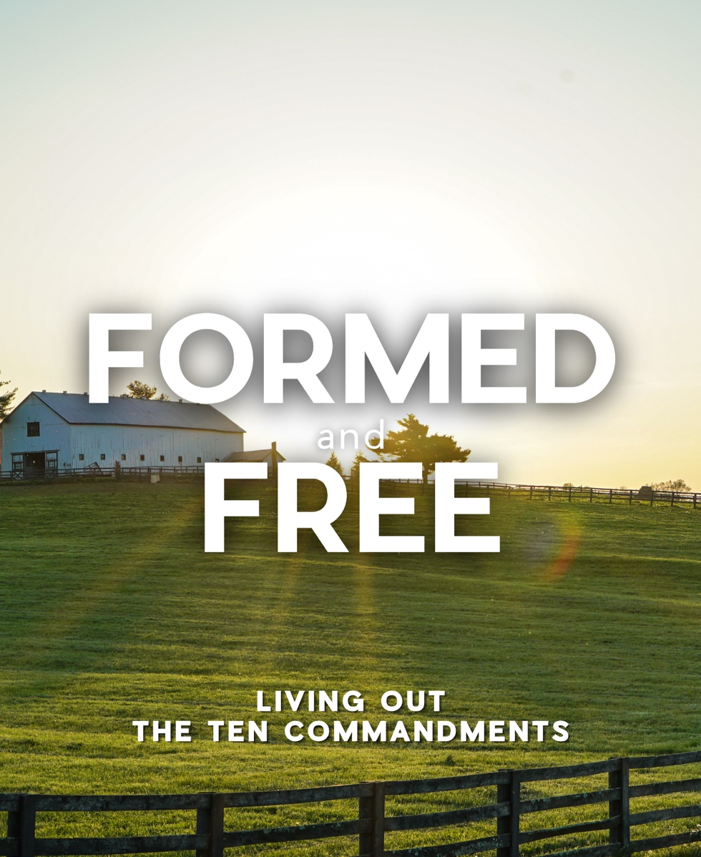
Worship
July 5, 2026

The Village Church
Joining God’s Mission in Everyday Life
1300 Shermer Road, Northbrook, Illinois 60062-4577
villagechurchnorthbrook.org
847-272-0900

